March, 2020

How to be a
Webinar Master

Contents

Part I – Your webinar 4
Do webinars need to be dull? 4
Making webinars work for you 6
Step 1: Craft your story 10
Step 2: Start well 15
Step 3: Provide great, engaging content 19
Step 4: Sharpen your delivery 26
Step 5: Master chat and Q&A 30
Step 6: Prepare yourself 33
Part II – Around your event 36
Before, during and after your session 36
Technical considerations 38
Webinar platforms 39
Part III – Supporting materials 41
Check lists 41
Resources and references 43
Acknowledgements 44
About the author 44

Introduction, 2020 edition

This book was originally published in September 2015 by Canelo press. Nearly five years later, amid the corona virus outbreak, there is a surge in people wanting to deliver online. I am, therefore, grateful to Canelo’s founder, Michael Bhaskar, for permission to issue this slightly modified version for free. (By the way, Canelo does a great line in e-book fiction.)

I was prompted to distribute this book by a webinar I gave on Thursday 19th March 2020, entitled ‘Moving your L&D online – fast’. Despite minimal promotion, the webinar room rapidly filled up to the capacity of 250, with some unable to attend. I knew then that I should distribute this book as soon as possible. Having re-read it several times, I can say that the contents remain absolutely relevant and reflect how I still work. I have only made a handful of alterations to the text.

These are difficult times, and many people in our field of Learning and Development are being called on to accept new challenges at unprecedented speed. Please, if you can, regard this as an opportunity to embrace new practices, and serve those whose learning you support even better. There are unique things that can only be done in online delivery. I urge you to embrace them, and wish you good luck in whatever challenges you face.

Donald H Taylor
London
March 2020

Web: https://donaldhtaylor.co.uk
Twitter: https://twitter.com/DonaldHTaylor
LinkedIn: https://www.linkedin.com/in/donaldhtaylor/

Introduction to the 2015 edition
This book is based on my experience hosting and delivering hundreds of webinars since 2007, largely for the Learning and Skills Group (LSG), an international community of about 8,000 learning and development professionals.

It will make you a webinar master – if you put it into practice.

I’ve had the good fortune to work with some wonderful, experienced speakers, and had the delight of seeing the first time speakers I’ve coached deliver tremendously powerful sessions. I’ve seen what works and have built up a methodology for consistently delivering great webinars. The fruits of that experience are gathered here for you.

As well as the triumphs, I’ve also had my share of disasters – from the time the webinar service failed two minutes before we were due to start (with me in a New York hotel room in my pyjamas at 5 am) to the time both the broadband internet feeds at my home office failed and we ran the session through my mobile phone’s Wi-Fi tethering. In all the hundreds of sessions I’ve been responsible for in that period, we’ve only once been unable to get on air.

It’s been an exciting journey, and the thrill hasn’t gone yet. I still get excited before we kick off one of our Thursday LSG sessions, and still feel that buzz when a presentation and the ensuing Q&A have gone particularly well. And after every webinar, I want to do it all over again.

I hope that after reading this book, you too will enjoy presenting through webinars, and that you will discover the energy and excitement of using this vital modern form of communication.

Happy presenting!

Donald Taylor
London
September 2015

Part I – Your webinar
Talking is completely natural. It pre-dates human history. It’s likely that some form of language pre-dates even Homo sapiens. And when you watch a group of people for a while, very often just one person will be doing the talking, while a group listens. He or she is doing a very low-key form of public speaking.

This book is about taking that very natural process of speaking to a group of people and helping you do that online, to an invisible, unknown audience.

There is no real difference between the intimacy and informality of a conversation with friends and what you say online. You still need to be engaging, and to know your audience. If you are also fully prepared, you will do an excellent job.

Do webinars need to be dull?
In this book I use the word ‘webinar’ to mean a particular type of event – an online presentation where the speaker(s) and audience are connected through computers, linked together over the internet. The presenter almost always has slides to show, and will sometimes also be visible over video. There is usually at least one other person involved – often an MC or host, who introduces the speaker and who may also handle a Q&A. Typically, the audience can use the webinar chat function to communicate with each other and with the speaker; sometimes they can also speak.

There is nothing in this rather wordy description requiring that webinars be dull. Nevertheless, that is their general reputation, and for one very simple reason: most events involve no interaction and no attempt at engagement. The audience is expected to sit, listen and look at slides.

Sometimes, this is not an issue – the subject matter itself is compelling enough. For most, however, it is a recipe for the audience quietly dropping out of the event, or perhaps half-listening while catching up on email.

Unless you have something to say that is utterly compelling, you will need to engage your audience and interact with them to make your webinar a success. Fortunately, that is exactly what this book is about: from using your voice, to structuring your story, to asking and answering questions.

But rather than starting on this slightly negative note, it’s worth reminding ourselves of three real benefits of webinars.

First, they are convenient. Unlike face-to-face meetings, they involve no travel, and unlike telephone conferences the availability of visuals and text chat makes them a rich medium.

Second, if you are speaking on a webinar you can have all your notes, including a script, immediately to hand. In other words, if you are sufficiently prepared, it is a very low-risk event.

Finally – and this is a point I cannot emphasize enough – the text chat offered by webinars provides a unique opportunity. In a face-to-face event you cannot have everyone talking at once, but online anyone who has something useful to contribute can do so, quickly and without interrupting the speaker, just by writing a short message in the text chat area. Everyone can see these contributions, and they are available for reference after the event.

Time and again over several hundred webinars, I have seen audiences add insight, thoughts and resources to a discussion in a way that I cannot imagine happening face-to-face. I do not say this to denigrate in-person conferences or workshops – I have chaired scores of them – but rather to highlight an important fact: webinars are not the poor man’s meeting. Use what they have to offer and you can create memorable events with great impact.

A simple webinar layout
Webinar platforms offer a wide range of functions, including whiteboards, breakout rooms and much else. All of them, however, include the ability to show slides and for people to chat, which are the core of any webinar. Typically these are displayed like this:

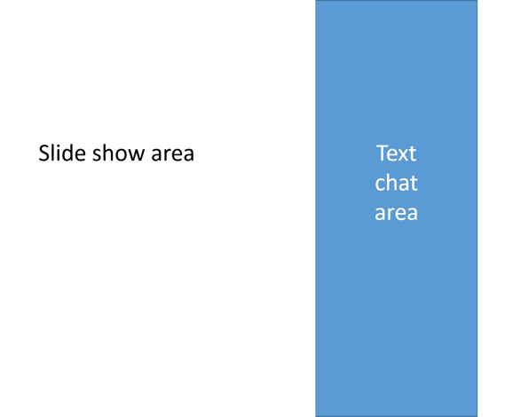
- Typical webinar screen layout – attendees’ view

In this view, attendees see just two things: the presenter’s slides and a text chat area, which everyone (speaker, host, attendees) can see and contribute to. I strongly believe that an effective webinar relies on live contributions from attendees. If your platform does not offer a chat area which everyone can contribute to, and read, then I would change platform.

I call the main area the ‘slide show area’, because most often it is slides that are being shown. However, it is worth noting that a webinar need not be confined to slides. Speakers can also show documents, videos and other file types, as well as using this area for interaction – for example, with a virtual whiteboard which all attendees can write on.

Usually the speaker on a webinar can see more than the attendees. For example, the speaker might see this:

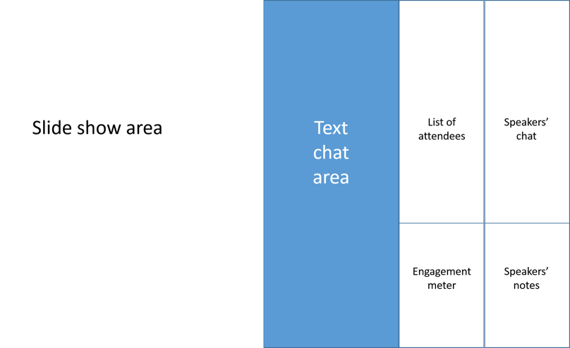
- Typical webinar screen layout – speaker view

Here, the speaker can see the list of attendees’ names, the engagement meter (a way of measuring how many of those attendees are actually looking at the slides), some notes for speakers to use, and an area for private chat just between the speaker and the host. This layout is just one example of what is possible with most webinar platforms.

Chat and interaction
Most webinar platforms include a wide range of tools to enable interaction, including breakout rooms, whiteboards, mark up tools, speaker video and so on. I would encourage you to investigate these tools and find the best ways of using them.

In this short book, however, I will concentrate on the one tool which I have found stimulates more interaction than any other: the text chat area. Simply prompting people to share their observations, comments and resources and letting them get on with it has always provided enormous value for attendees, kept them engaged with the event and helped them interact not just with the speaker but also with each other. To make the most of any webinar, be sure to facilitate a vibrant discussion in the chat area, both between you and the attendees, and among the attendees themselves.

Making webinars work for you
Let’s start at the beginning.

The essential point about online sessions is this: the audience’s only interaction is via their computer screen and speakers. Obvious? Yes, but precisely for that reason, it is easy to overlook how wide the implications are.

Because the audience members are separate from one other and from you, three lines of non-verbal communication are removed, lines that we take for granted during a physical presentation. The audience cannot communicate with you non-verbally, nor with each other, nor can you communicate non-verbally with them. The result is that online presentations require you to think very clearly about how you will build rapport with your audience, engage their interest and maintain it.

When presenting online, without recourse to non-verbal communication, your voice becomes a vital tool. It must be clear, varied and well-modulated. Using a set of wordy PowerPoint slides as a script for ad-libbing is a poor approach when you are physically in front of people. Online it is a disaster. To succeed at presenting online you need compelling, well-structured content that involves the audience.

There is not a great deal that is new to learn, but any online presenter will have to remember not to use many of the habits, tricks and instincts built up over years of face-to-face delivery. The good news is that anyone can present online, and it enables you to do things you cannot easily do in the physical world.

Presenting online isn’t very hard: I estimate that it’s about as difficult as driving a car. If you can do that, you can present online. Of course, if you drive, you’ll also remember how impossible co-ordinating everything seemed at the beginning: looking at the mirror, controlling the clutch, watching your dashboard… You’ll also remember how you overcame all that to become the confident driver you are today: through practice.

Our noisy, multi-stream information culture
From watching TV to interacting with friends, the way we live reflects our noisy, multi-stream information culture. People are increasingly habituated to using Twitter while they watch TV, or seeing multiple streams of information alongside the sport or business news. Whether it’s live voting on talent shows, or TV screens simultaneously showing the results of three different sports while discussing a fourth, information-rich culture is now mainstream and – consciously or not – your audience expects it.

This profoundly affects the way people attend webinars. Many participants are used to dealing with plenty of information at once. Some even feel cheated or under-stimulated without it. Unlike their counterparts 20 years ago, almost none of your attendees will feel comfortable sitting quietly and listening to a presentation for 40 minutes.

People have learned to deal with this information overload with short bursts of highly focused attention. We typically focus on something, and if we don’t find it worth our attention, shift focus to something else. When that attention shifts, it takes a lot to bring it back.

This does not mean that presenters should resort to snake oil, blarney and theatrics. On the contrary, it means that when the attendee is focusing on the event, she must find something useful in it. That could be the presenter’s content, their voice, what’s on display, or the text the attendee are reading on screen or in the text chat area.

In other words, in this busy age, the secret to a successful webinar is simple: provide compelling value.

The implications of noise
One consequence of our noisy, busy lives is that a webinar is not the place to convey a lot of new information that demands instant digestion or reflection.

Most webinar delegates work in a noisy environment – both literally and figuratively. They are often attending webinars in open plan offices, with other applications as well as the webinar software open on their screens. They may well be interrupted by work colleagues during the event, physically or via the phone, and they are only ever seconds away from checking their email.

This noisy environment is something you will have to take into account when designing your talk. Your presentation will need to be engaging, clear and constantly on the move.

The key roles in a webinar
Although this book is about delivering great webinars, it is important to remember that delivery is only one of the roles essential to a successful webinar. I reckon there are six key roles. It is possible, even usual, for one person to fill more than one of these. It’s even possible for one person to fill all of the first five:

- Presenter – creates and delivers the content
- Host – facilitates the event, does introductions, Q&A, watches chat
- Producer – chooses topic and presenter, schedules rehearsals, may edit content
- Marketer – ensures sufficient delegates turn up, and with the correct expectations
- Administrator – deals with technical issues
- Attendee – needs clear expectations and an understanding of webinar etiquette

This book concerns the first of these roles, but remember that if the other roles are not fulfilled, even the best presentation will fail.

The six elements of a webinar
A webinar is made up of six elements. In order of importance, they are:

- Content
- Voice
- Interaction
- Structure
- Anecdotes
- Visuals

While each of these is necessary for a successful event, none is sufficient by itself; a webinar without visuals is a radio show, without anecdotes it’s a lecture, and without good content it’s useless. For the purposes of this book, I’m going to assume that you have content useful for your audience, and we’ll concentrate on the other five elements.

Not everyone will agree with this ranking, so let me explain why voice is at the top and visuals at the bottom.

I’ve hosted webinars where people have done a great job engaging with the audience using their voice alone. With very simple slides of just a few words, they initially set out a point of view, then answered questions and engaged with the audience, who were entranced and left delighted with how they’d spent that hour. Voice and interaction, then, have to come first.

Visuals are the least important for two reasons. First, bad visuals can break a presentation, but adequate visuals will get you by. Adequate content won’t, and an adequate voice will only work if your content is stellar. Provide only adequate interaction and you’ll lose a substantial part of your audience. Your structure can be basic, but it must be well thought through, and your anecdotes must be carefully selected, honed and rehearsed. Visuals, then, are forced to the bottom of the list.

Secondly: it’s easy to spend a lot of time on visuals, persuading ourselves that we’re working on making our presentation better, when in fact all we’re doing is being busy. Get the visuals good enough, then work on the rest of the list and come back to the visuals once you’re sure everything else is okay. If you find you can’t polish the visuals to your satisfaction, that part of your presentation can always be subcontracted. Working on your anecdotes, content and voice can’t.

As I say, however, all six of these elements are necessary, and the richness of a well-prepared, well-delivered webinar comes through their interaction.

Here are the key steps to becoming a webinar master, all of which are covered in this book:

Step 1: Craft your story – decide on the point you want to make and stick to it.
Step 2: Work with the audience – structure your presentation to allow you to build and retain rapport and interest.
Step 3: Build and maintain visual interest – this is not about pretty slides, it’s about making your point well.
Step 4: Sharpen your delivery – your voice is a vital tool in a webinar. Use it well.
Step 5: Master Q&A and chat – this is where participants get real value.
Step 6: Prepare yourself – this is often the difference between success and failure.

Step 1: Craft your story
Let’s assume you are delivering a one-hour webcast. During this you may only be presenting for some 30 – 35 minutes, with the rest of the time going to housekeeping, a Q&A, and wrapping up.

How will you make those 30 minutes count?

When speaking online, you can’t rely on body language, and as a result your content becomes supremely important. In fact, it is the essential element, more important than your voice, than interaction, than beautiful slides. Content trumps them all.

In addition, because your audience almost certainly is not in the habit of sitting and listening to something for 30 minutes at a time, you have to be absolutely clear about what you’re saying, to give them a compelling reason to stay. So the key point of a successful online session is this: have a point and stick to it. By ‘stick to it’, I mean that every word of the presentation, every question, every analogy, metaphor and piece of information should lead to or reinforce that point. If it doesn’t, throw it out.

When William Goldman wrote the screenplay for the film A Bridge Too Far, the tale of the airborne assault on Arnhem, he knew British soldiers had won five Victoria Crosses (the highest British military award for gallantry) during the battle. He wrote each into the script then cut them all out. Why? Although each was a dramatic story, none played a part in the structure of the film he was writing. You have to be just as ruthless when writing your presentation – for each point you make, ask yourself: how does this advance my story?

Your content
There is just one rule: be useful.

Of course, your content will be useful and of interest to the audience, we take that for granted. So will the audience. It’s why they turn up. Some considerations to make sure you get the most out of it:

- If in doubt, have too much content rather than too little (but not so much you’ll have to rush it)
- The actionable, practical and real is always preferable to the theoretical
- Avoid hyperbole, spin or marketing

Assembling your thoughts
It’s very common to have a general idea of what you want to say, but to be a little hazy on the details. If this is the case, the worst thing you can do is to start writing a script or building a PowerPoint slide deck – you will begin too far along the creative process. Instead, here’s a process that will help you collect your thoughts and assemble them so that you not only know the key point you want to make, you also have the material to support it, and a clear benefit for your audience:

- Brainstorm – indulge in the pleasant activity of just writing down on paper everything you can think of that’s associated with the subject. I use a mind map for this.
- Clarify – now take the time to reflect on what you have written. Underline the most important thoughts, and as you do so your key point should become clear. You should also now be clear on the benefit for your audience in listening.
- Synthesize and discard – now that you have your key point and the proposal to your audience, you can begin to cluster together the headings and thoughts that best support them. For an online presentation, aim for two to five headings supporting your main point. Discard anything superfluous.
- Order and write – your cluster of thoughts will suggest an order themselves, for example chronological, problem/solution, or cause/effect. Use this to order the headings you developed in stage three, then start writing your slide deck.
- Edit and write again – while you are rehearsing your presentation, you will find many ways to improve it, in terms of running order and content. Edit your presentation accordingly. Never go with your first draft.

Be brutal with your anecdotes
We are, by nature, tellers of tales. We have grown up listening to them, we tell them all the time, and our audience expects them. So find the right ones and use them well. (A word on definitions: in this book I use the word ‘story’ to refer to the single, overall thesis of your presentation, and ‘anecdote’ or ‘tale’ for the illustrations we use to support that story.)

There are plenty of lists of types of anecdotes, the most notable among them Christopher Booker’s 2004 book The Seven Basic Plots. Following his Jungian terminology, your own anecdotes are likely to be fall into either the Overcoming the Monster or Quest plot types.

Whatever type they are, my experience hosting hundreds of webinars tells me that every webinar needs to combine anecdotes with a logical structure if it is to present a fully realised story. The structure provides your attendees with a sense of a coherent whole; the individual anecdotes are vivid illustrations that tap into their emotional side. Anecdotes without structure can seem pointless, structure without anecdotes sterile.

One thing you must do with your anecdotes is to be brutal in choosing them. Only pick those that fully support your thesis and structure. Once they are picked, hone them down to a short, tight form devoid of rambling and unnecessary explanation. Aim for no more than a minute per story. And finally, rehearse your story until – paradoxically – it sounds spontaneous. Remember Oscar Wilde’s words: "Spontaneity is a meticulously prepared art".

Structure
In the past, people sat through rapidly delivered sermons and plays and took it all in. (In Shakespeare’s time, Romeo and Juliet was said to require just a ‘two hour traffic of the stage’. Today it’s more likely to last three.) Nowadays people are less aurally practised, so once you have your point, break it into parts or topics, and signpost each one to the audience both verbally and with ‘signposting’ slides. In other words, stick to the old adage:

tell ’em what you’re going to tell ’em
tell ’em
then tell ’em what you’ve told ’em.

As well as telling your audience verbally, use signpost slides throughout the presentation to show visually where you are in your structure. I find a combination of words and pictures works best:

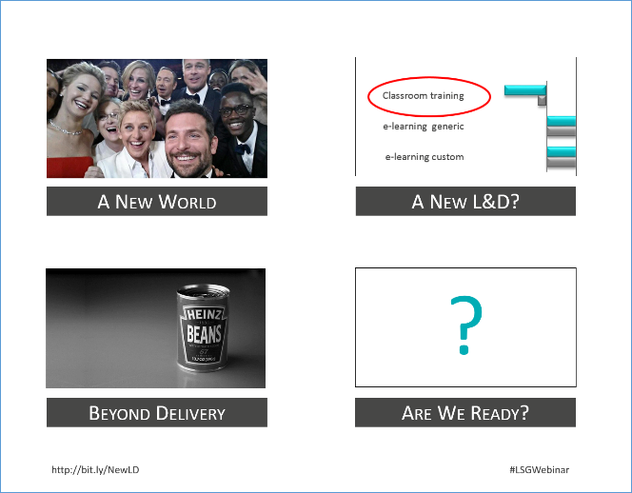
- Agenda slide

A slide like this at the beginning provokes interest. At the end it acts as a summary, and the images as visual clues. During the webinar I will also use it to remind people where we are in the running order, by greying out the rest of the agenda:

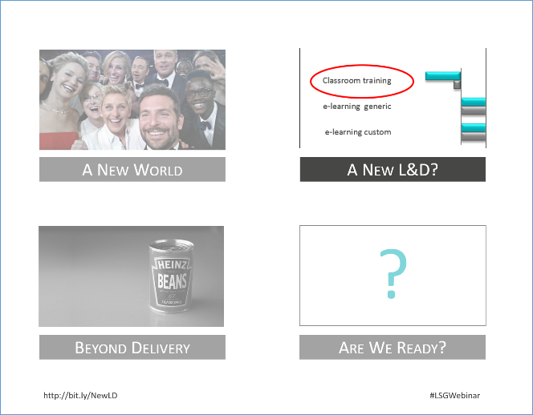
- Agenda slide during presentation

An example structure
Given that structure is so important to a presentation, here is an example structure for a 20-slide presentation that will take – depending on content – about 30 minutes to deliver, depending on the content. Clearly, it’s a generic structure which you could adapt to your own needs. The important thing is that it has a clear beginning and end, and three well-structured sections in the middle, although it could contain anywhere up to five:

1. Holding/title slide
Title, start & end time. Speaker photo and name. May also have a brief overview of tools available to delegates.

2. Open question
An open question relevant to the topic and the experience of the audience. Comment sensibly on the results.

3. Agenda
The structure of the talk.

4. Section title 1
A signpost: “Now we’re going to talk about Topic 1. This is important because …”

5. Content slide
Could be a diagram, a demonstration, a picture, a quote or just words (but not too many).

6. Content slide
As above.

7. Content slide
As above.

8. Question slide
Summarise this topic or lead to the next.

9. Section title 2
A signpost: “Now we’re going to talk about Topic 2. This is important because …”

10. Content slide
Could be a diagram, a demonstration, a picture, a quote or just words (but not too many).

11. Content slide
As above.

12. Content slide
As above.

13. Question slide
Summarise this topic or lead to the next.

14. Section title 3
A signpost: “Now we’re going to talk about Topic 3. This is important because …”

15. Content slide
Could be a diagram, a demonstration, a picture, a quote or just words (but not too many).

16. Content slide
As above.

17. Content slide
As above.

18. Question slide
Summarise this topic or lead to the next.

19. Wrap up
Tell ‘em what you’ve told ‘em.

20. Q&A placeholder with contact details
Ideally, the Q&A should last at least 15 minutes, if well handled.

This structure should not be seen as prescriptive. For example, the question slides could come before or after the title slides for each section. The only two things you must have in your presentation are questions and structure. I have hosted and run successful webinars ranging from 5 slides to 50. The five-slide presentation was simply a series of assertions, which we discussed together as a group. Each slide served as content, question and structure. Focus on questions and structure and let common sense be your guide to the rest.

Step 2: Start well
If you start well, you will set your webinar up for success. This chapter describes how to do it, beginning with the crucial first moments where you build rapport.

Build Rapport (slides 1-3)
In the example structure above I suggest opening with three slides:

1. Holding/title slide
Title, start & end time. Speaker photo and name. May also have a brief overview of tools available to delegates.

2. Opening question
An open question relevant to the topic and the experience of the audience. Comment sensibly on the results.

3. Agenda
The structure of the talk.

Build up and title slide 1
With a physical audience, rapport is won or lost very quickly – usually within the first minute a presenter is on stage. The audience’s first impressions of a speaker are based on how they are introduced, their body language as they step up to the stage and begin to speak, and the manner in which they deliver their first few sentences.

An online presenter’s rapport with her audience is never as strong as one developed in person, but it exists, and it is built by ensuring that your audience feels comfortable that they are in expert hands. You can foster this trust by ensuring:

- There is a holding slide before the title, stating the presentation title and start time, so that attendees know they are in the right place
- You have done a technical rehearsal to ensure there are no software glitches
- You start on time
- You speak fluently from the start, with no hesitation or sense of insecurity
- Your voice is enthusiastic and you speak at the right pace. Online, your voice is your body language, dress sense, posture and smile all rolled into one. Use it well.

For these reasons, it is a good idea to have a facilitator or host presenting with you who can deal with any technical issues that may come up. If necessary, he or she can watch out for questions and text chat while you talk. This will enable you to concentrate on presenting. With experience, you will find that you can talk, use a keyboard or mouse and respond to chat messages simultaneously.

On the holding slide, make sure that you have the following information:
  - Name and affiliation of speaker
  - Title of webinar
  - Start time and run time
  - Any relevant notes
  - Photo of speaker – especially if you aren’t using a video cam on the speaker

I would not spend a lot of time talking over your holding slide before you start. By all means, chat to your audience using the text chat box – a great place for rapid interaction between members of your audience – but do not expose your voice too early, except perhaps to say ‘we’ll be starting in five minutes’. The risk of speaking without a presentation or script – especially if you are new to the medium – is that you may ramble, which can weaken your rapport with the audience. It’s also unfair to begin on your topic before all participants have arrived.

On the other hand, if you have a facilitator, they may choose to engage with the audience verbally before the webinar starts. This is my role in the Learning and Skills Group webinars, where I usually begin by asking people where they are from, and what the weather is like where they are. This innocuous task lets new participants get the feel of using text chat in a completely risk-free way – both expressing themselves and interacting with other members of the audience.

When you begin the webinar (bang on time), put up your title slide and introduce yourself, your background and your topic quickly.

It’s essential at this point to be concise.

Cut your own profile back to a few points that establish that you’re worth listening to. As for the topic, avoid empty statements such as “this is really important” unless you can back them up with solid facts. Early arrivals could already have been online for ten minutes or longer, and they don’t want to listen to another two minutes on how wonderful you or your company is – they want to get going. Just handle the basics in about twenty to thirty seconds and move on. The easiest way to do this is to have a script or detailed notes prepared. This is the right point to establish your credibility, but do it with hard facts and in as few words as possible. When I’m speaking, here’s how I typically introduce myself:

‘Thanks, [name of host]. As [name] says, my name is Donald Taylor. I’ve been in learning and/or technology since the mid 1980s. I’ve done everything from programming to classroom training to designing courses to running operations to setting up and selling companies. I’m currently the chairman of the Learning and Performance Institute and the Learning Technologies Conference – the largest event of its type in Europe. Today we’ll be discussing …, a topic of increasing importance today because of …’

In under 30 seconds, I have – hopefully – made people comfortable that I have some experience in the field and will be worth listening to.

Your opening question (slide 2)
If you were running a physical event, you might have spent time talking to people before you kicked off and getting a sense of what they wanted – you’d want to frame your opening remarks with this in mind.

For the same reason, use a question as your second slide. Listening to what your audience has to say will help you shape your initial approach, enabling you to build rapport with them.

But the opening question has other benefits as well. It sends two messages to the audience immediately: the speaker is in control, and this is an interactive presentation. Participants have to sit forward. This is not a time for them to catch up on their email. Also, if it is an open question (and it should be) then you’ll find it primes the pump for activity in the text chat area. After a few answers, people start responding not just to the question, but also to each other. The result is a glorious flourishing of interaction as people engage with, and contribute to, the session.

All this from one open question!

Typical open questions with which to begin a session might be:

How are you using mobile content delivery in your organisation?
Can you give an example of a time when you … ?
How are you evaluating learning in your organisation?

You get the idea. Ideally, the questions should be open, personal and relevant to the topic. Asking ‘What are you hoping to get from today’s session?’ is too vague. Being specific helps people focus and respond.

Be quite clear in your instructions, both verbal and written, about how you expect the audience to respond – in this case, by typing in the text chat area. This clarity ensures people spend their time engaged in the topic, not wondering what you want from them.

A word here on writing questions on slides. Speakers often ask me if they can just ask a question verbally, and the answer of course is yes, and dropping questions into the presentation ad hoc should be encouraged. However, if you really want a response (and at the beginning of your talk you certainly do) then you need to present the question clearly using the written word, probably on a slide. Say it once, and many people will miss it, and then it’s gone. Write it down and even the most distracted delegate will see what is expected.

As with any question, respond intelligently to the answers given. ‘That’s interesting’ will not do. Try something like ‘I can see that a lot of you have reported problems with the ABC software package in the past. That’s more than I would have expected. Let’s look at that now…’

Remember to credit people by name. They’ve exposed themselves to public scrutiny by delivering an answer to their question, so you should acknowledge the value of what they’ve shared.

Don’t spend too long on the question slide and the answers: perhaps 30 seconds to a minute. Ideally, discuss it with your host. Listening to two voices is more interesting than one. Reflect on the answers, and then move on.

My golden rule is that whenever you ask a question, the following slides should reflect that question and the answers the audience have given. In this case, the next slide is your agenda, and your opening question sets you up nicely for it.

Your agenda (slide 3)
On the agenda slide, refer back to the answers already given. You might say something like ‘A few people mentioned that demonstrating value was difficult, and we’ll be examining why towards the middle of today’s session. First, though, I want to establish why it’s so important. As Amy pointed out …’

As with any presentation, the aim here is clarity. The audience now knows what you aim to achieve, and they are ready to listen and engage because they have already started thinking and chatting about the topic.

The agenda slide is the final piece in engaging your audience’s interest. It should list the three to five key headings that you chose when assembling your content, and should recur at each section break to remind your audience where you are in your talk.

A note on surveys/polls
Surveys are in some ways great for involving the audience: everyone can contribute without exposing their opinions, or having to type. On the other hand, because gathering the responses typically takes a minute or two, surveys can easily slow down a presentation. You risk losing your audience as they wait for the results to be shown and discussed. After all, it only takes a moment to select a response, but they will typically have to wait at least a minute for the results. During that minute, your audience’s inboxes will be beckoning them increasingly forcefully. Use surveys sparingly, and only when you really need a numerical answer. I tend to use them at the beginning of a presentation, where their impact on the presentation’s momentum can be minimised.

Step 3: Provide great, engaging content
The core of your presentation is its content. Content is what people come for, what they stay for, and it’s what they will remember afterwards – provided it is high-value content, put over well.

To make your content compelling, you need to do two things: ensure it tells your story clearly, and make it engaging.

In the context of webinars, ‘content’ generally means ‘slides’, and there are plenty of great resources on how to design your slides and graphics.

Because so much good work already exists on slide design in general, in what follows I will concentrate on the detail of effectively relaying information in order to tell your story.

I have distilled my advice into six principles. I don’t claim they are either exhaustive or the result of scientific analysis. They are, however, based on my experience of gauging audience reactions to thousands of slides in hundreds of presentations, and I apply them when delivering my own presentations and when training presenters.

The six principles for creating engaging content
#1 People can’t stop themselves reading
#2 People don’t listen well online
#3 Images have impact
#4 Variety provokes attention
#5 Our eyes follow motion
#6 Words work

#1 People can’t stop themselves reading
When people are presented with writing on a slide, they cannot help but read it. If there is a lot of text, two things follow. Firstly, you lose your audience. They stop paying attention to you, because most people cannot simultaneously read and listen effectively. Secondly, they get frustrated, because they hear you speaking, know they should pay attention, and are torn between the two tasks they feel themselves presented with. This can all happen in a matter of moments, after which they may well give up on reading the slide, so there wasn’t much point putting it up there in the first place.

This is the reason you should never create slides consisting of lots of text or bullet points – not because people won’t read them, but precisely because they will try to and become frustrated. I’m not suggesting that you shouldn’t put words on slides at all. Rather, I am suggesting that the text you do use should require almost no effort to read. Ideally, you should be able to read it in a single glance, like a road sign.

Each year, Laura Overton presents the findings of her Towards Maturity research into the quality of training departments. She has hundreds of thousands of data points stretching back to 2005 which she can draw on. This means that each November, when she presents the new findings, Laura faces a dilemma: which data points are the most important? In preparing for the launch of her findings, she makes merciless decisions about which points to focus on, finds punchy graphics to support them, and makes it clear why they are important.

Here’s an example where Laura has chosen just one number and one piece of contextual information from all those thousands of possible data points and comparisons. This slide makes her point – that 29% of e-learning is e-enabled, but most of it is about compliance – far more vividly than it would if it were buried in a slew of other data:

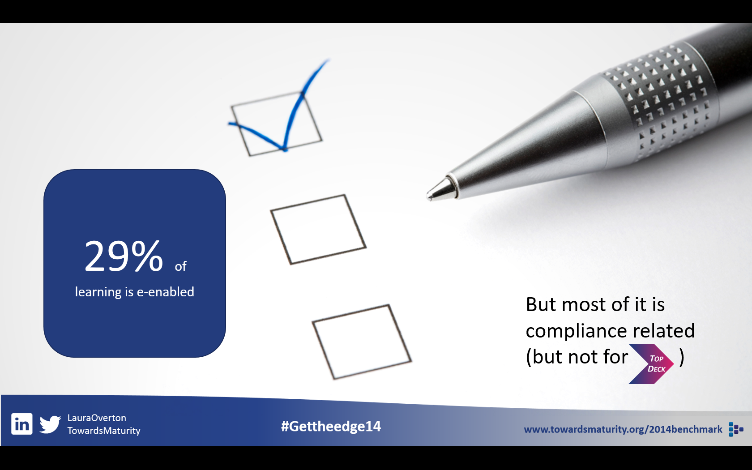
- Picking out crucial messaging

Sometimes, however, you can’t avoid putting a lot of words on a slide. Here’s a slide I’ve used when I’m talking about the research into learning styles. I feel it’s important to use the entire quote to give the context. However, there is a real risk of the audience walking out when I do.

So I show the full quote, like this:
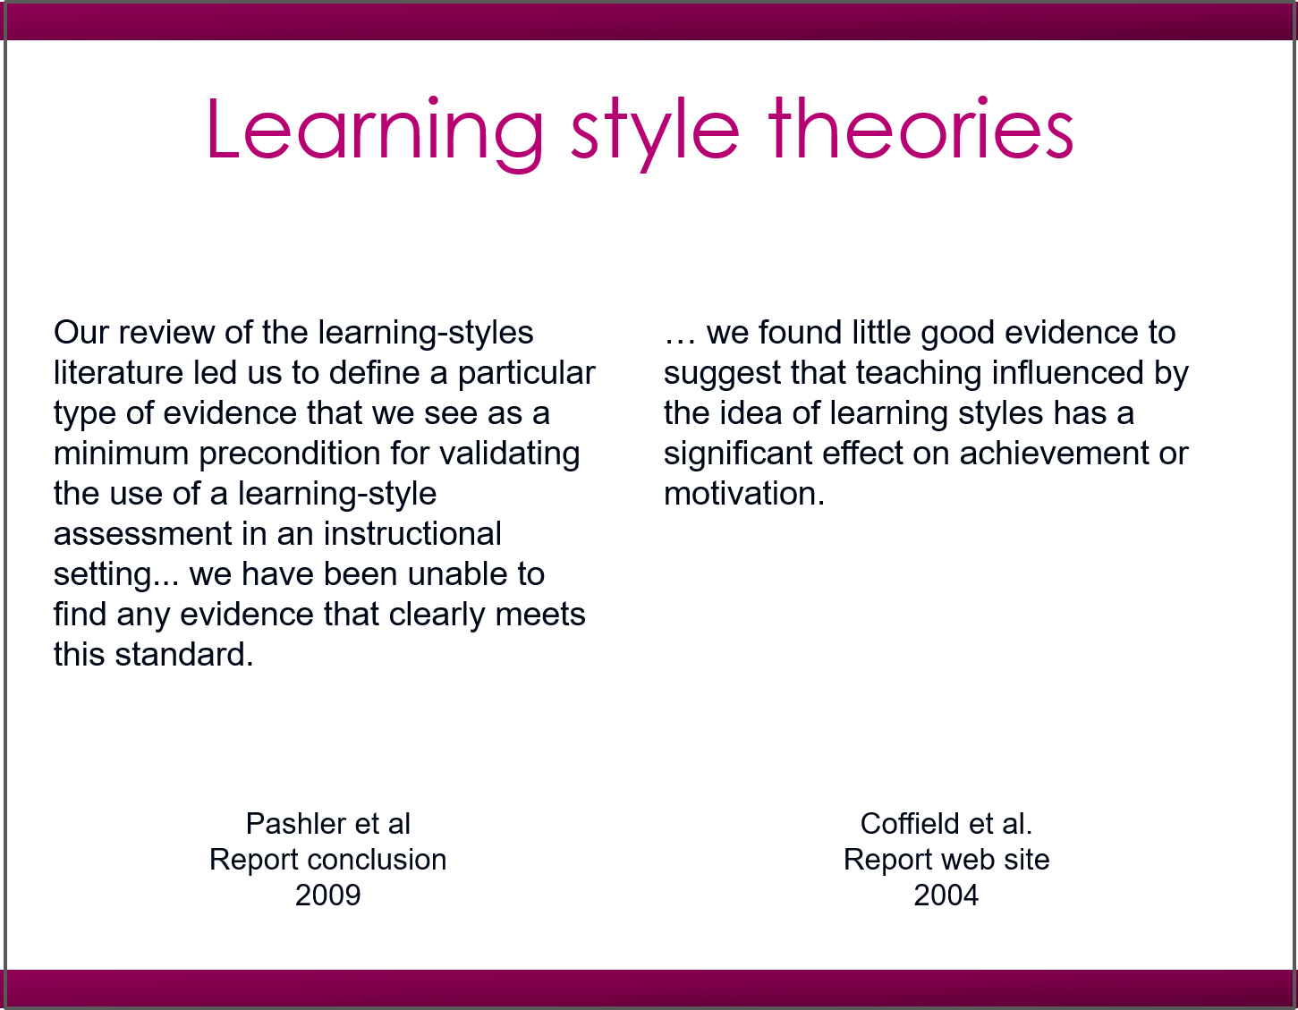
- Text-heavy slide

And say ‘but look, these are long quotes, I just want you to concentrate on the key parts of each’, then bring up the next slide:

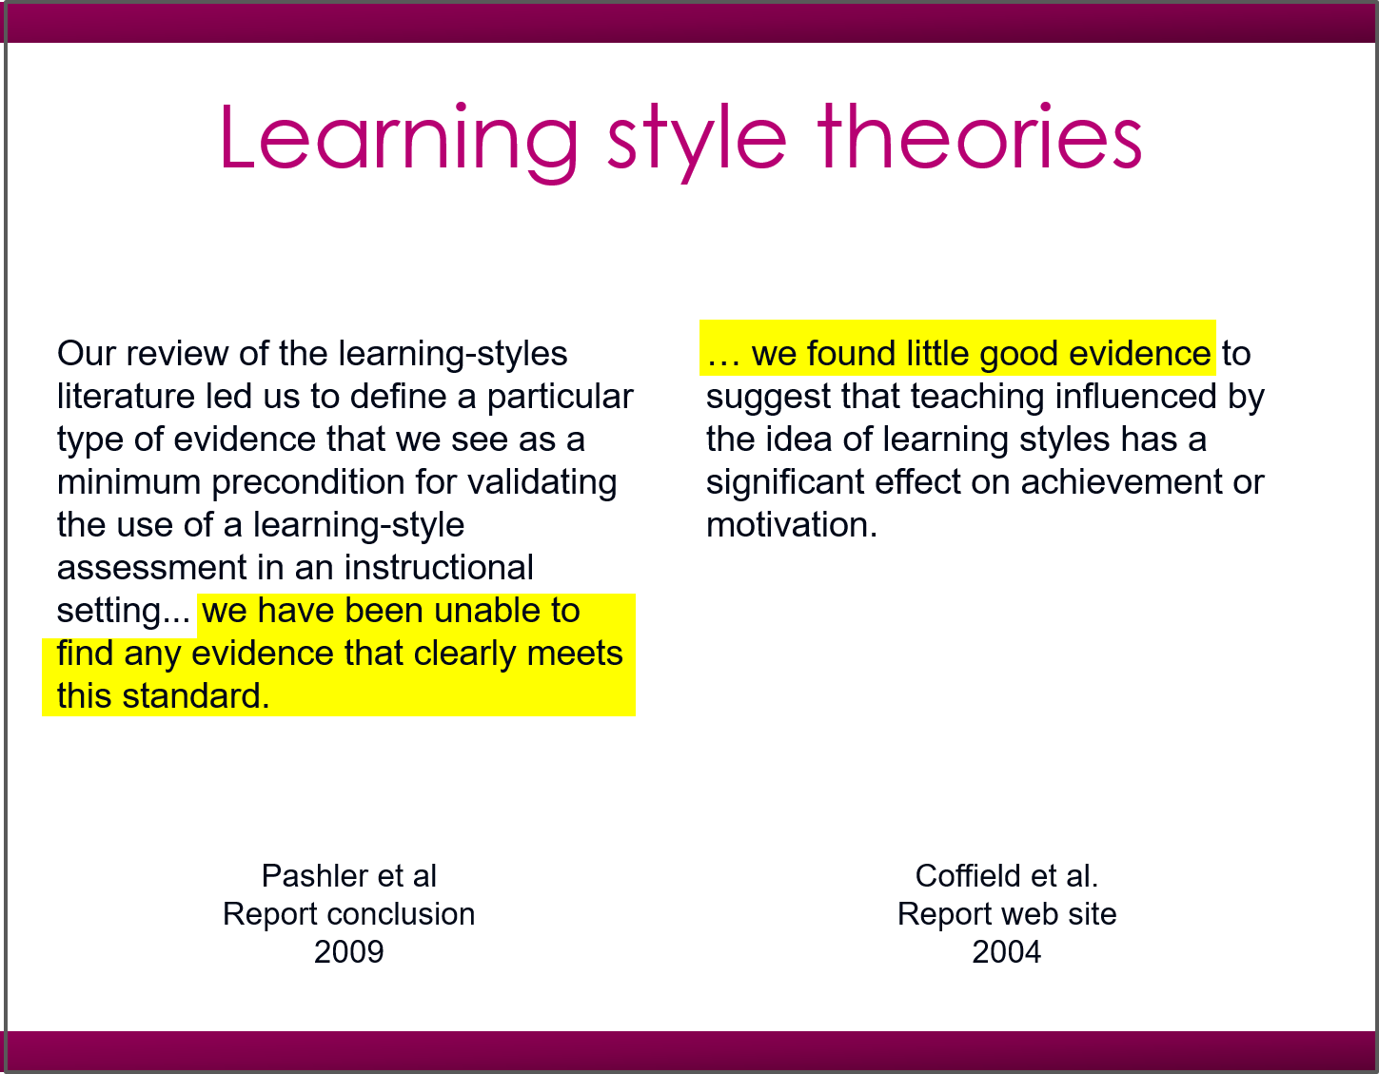
- Text-heavy slide with key phrases highlighted

After the initial confusion created by showing too much text, this focuses the audience on the key point – that learning style theories are not supported by research.

#2 People don’t listen well online
No matter how much they might want to, your audience won’t listen to you as closely online as they would in person. You can’t blame them for this: they are usually in a busy office and making an effort to attend your event despite the distractions around them. If you really need people to take action, then – in particular, if you have any crucial instructions you need them to follow – then present it in writing. This is particularly important for questions: relying on your audience to catch a question you ask on the fly means a proportion of them will miss it.

A question slide doesn’t have to be fancy. In fact, the simpler it is the better, as this will concentrate participants on the question. Just make sure the wording is clear:

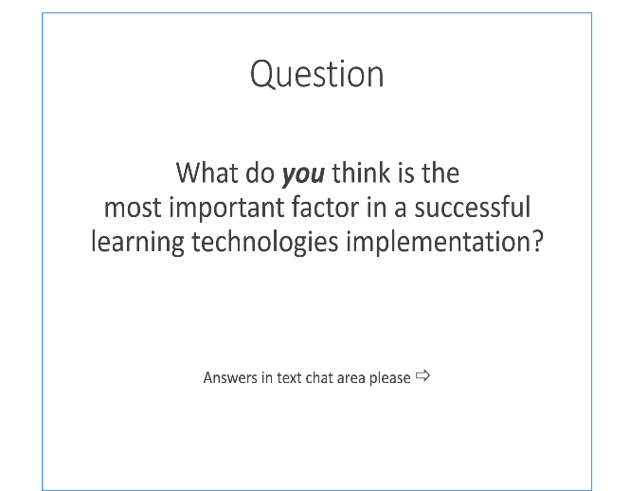
- Simple example instruction slide

#3 Images have impact
In his excellent Brain Rules, John Medina references many studies that show the power of images in helping us form long-term memories. The Picture Superiority Effect (also called the Pictorial Superiority Effect, or PSE) is absolutely unequivocal. In one experiment Medina cites, he points out that after being exposed to 2,500 pictures for around ten seconds each, people could still remember over 1,500 of them after a number of years.

Pictures immediately excite our emotions, too, in a way that words alone cannot. They can get people sitting forward and wanting to know more.

But images have their limits. In particular, unless you are actually talking about the pictures in question, it is not a good idea to use a series of images as the sole background to your talk. More than once I have watched audience engagement fade as a presenter talked for several minutes over a slide consisting of a single picture. The bewilderment would be conveyed in chat: ‘Why are we looking at a picture of a park bench?’ queried one participant, after a presenter spent two minutes on the same image.

Using images as the backdrop to a face-to-face talk is a great idea – they set the emotional tone for your content, and force the audience’s visual attention onto the speaker. Online, however, there is nowhere for that visual attention to go.

Online, then, use pictures for what they do well: for immediate impact and to set an emotional tone, then add words, diagrams, video or extra meaning.

You can also use images where you are keen for your participants to remember your content, but bear in mind that there are limits to PSE. In Sometimes a picture is not worth a single word, Joyce Oates and Lynne Reder point out that memory does not slavishly follow images. PSE, they note, occurs ‘when items are presented as distinctive, easy to label pictures’. If in doubt, add a word or two that can be read at a single glance (see principle 6, below).

This is why I usually use pictures and words in my agenda slides:

- That agenda slide again

Finally, be aware that the emotional impact of a picture can have unexpected consequences. One presenter of an LSG webinar wanted to make a point about how un-self-aware we typically are. As the backdrop to this discussion, he used a rear-view picture of an obese woman bending over. The rear of her track suit was labelled “Beauty”.

The result: the audience launched into a discussion about the photograph. Some thought it insulting, others funny, and some thought it was not making the point the speaker wanted it to make. It was a discussion that took about five minutes before we could agree to disagree about the photo and move on. I’m not saying the discussion was not worthwhile, but it wasn’t what the speaker intended; it destroyed the momentum of the talk, and it distracted his audience from the point he was making.

If you are going to use images to make a point, choose them wisely.

#4 Variety provokes attention
We have evolved to notice when things around us change. A hundred thousand years ago, on the African savannah, a slight change in our environment could represent danger or opportunity. Expect your audience to be alert to change, too.

At the same time, expect the inverse to be true: talking in a monotone will put any audience to sleep, whether face-to-face or online. Presenting a series of slides with exactly the same format will have much the same effect.

To avoid this, vary your slides – mix up diagrams with pictures, questions, words and online demonstrations. As well as using variety across slides, change things on individual slides to draw attention to the points you’re making. This technique is particularly useful if you have something complex to explain. Build it visually, step by step.

For example, here’s a slide I have used online where I wanted to draw attention to the slow, steady decline in the use of the classroom for training. There’s a lot of information on the slide which I needed to discuss, but I also wanted to draw attention to the change in classroom use.

On the first slide, I showed how training departments are increasingly using a range of media, and we discussed those, but I did not show the classroom number:

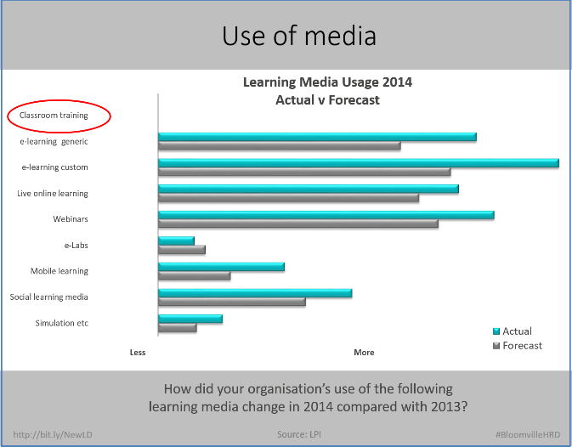

- Building information on complex chart – slide 1

I then asked the audience how they thought the use of classroom training might have changed (using a red ellipse to draw people’s attention to the top of the chart), and after a short pause, built the follow up slide:

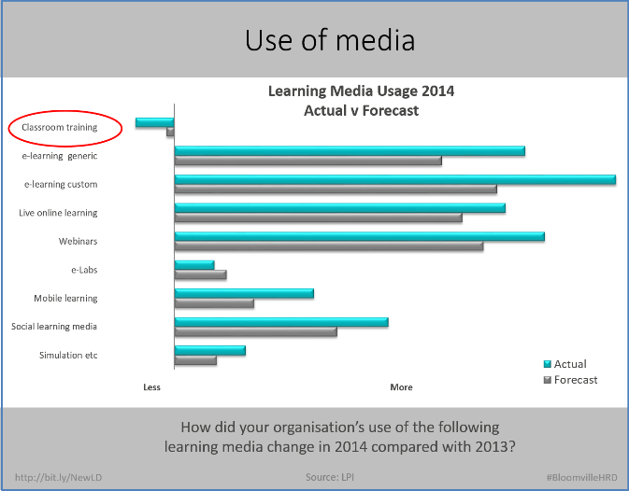

- Building information on complex chart – slide 2

It might have been possible to achieve the same effect by showing only this second slide, but there was a risk the audience’s attention would be scattered over the chart. This way I dealt with everything I needed to, one step at a time.

Variety, then, is useful, but always, always, do it with a purpose. If you use weird colours, cartoons that don’t fit the context, or anything else that doesn’t add value to the presentation, it will detract from it. Your participants are not stupid, and adding gimmicks to a presentation will only leave them feeling patronised. To paraphrase the Victorian designer and writer William Morris, add nothing to your presentation that you do not know to be useful, or believe to be beautiful.

#5 Our eyes follow motion
Motion is a specific type of variety, and probably the one we are most attuned to. With modern slide software, it’s horribly easy to provide motion without meaning – most obviously by building in words or paragraphs one at a time. Making your text appear in a fancy way does not add value to your presentation; showing a flow of movement through a process diagram does.

If you have some software to show, a live demonstration is always more interesting than a screen shot. Watching something happen usually excites our interest, and this principle extends to almost anything. On one LSG webinar, elearning expert Rob Hubbard asked an audience of over 100 people to complete a short SurveyMonkey questionnaire, and then, on the fly, with everyone watching, constructed a Wordle word cloud using the text from the survey. This was a great example of engaging content (the survey) and movement (the business of constructing the word cloud, which we all watched) and a great visual pay-off in the form of the word cloud.

When presenting your slides, at least some of the time you should use mark-up tools as you speak to highlight key words, images and parts of diagrams. This is the easiest form of motion to add, and it really adds value. Practicing marking your slides up is an essential part of rehearsing your presentation.

#6 Words work
As discussed above, the Picture Superiority Effect means that images grab our attention and stay in our memory, but if we want to add detailed, clear meaning, we need to add words to our slides – when it comes to conveying information, text works. However, they have to be the right words, and chosen carefully. Here are four things to bear in mind when writing slides for a webinar:

Use a few, well-chosen words
As I’ve said above, when writing for webinars, your text should be like a road sign – short enough to be readable at a glance. Cut, cut and cut again. Your text is there to support and emphasise what you are saying – not to be a script or a crutch.

By reducing your word count, you not only add impact to each remaining word, you also – crucially – reduce the risk of cognitive overload that comes with asking your audience to do two things at once (in this case, read and listen simultaneously). The LinkedIn Slideshare blog put this very well in The Scientific Reason why Bullets are Bad for Presentations. As Dr Chris Atherton explains, switching between reading and listening is exhausting.

Don’t use all capitals
Writing in all capitals has always been bad manners – too much like shouting during a polite conversation. But it’s also counter-productive – the variety of shapes and sizes in lower case letters makes them easy to read at a glance, according to graphic designers Jock Kinneir and Margaret Calvert, who redesigned British road signs in the late 1950s and early 1960s. This is why road signs in the UK read ‘London’ rather than ‘LONDON’ – it’s just that little bit easier to read. It’s also why New York City is spending $27.6 million replacing its iconic street signs, which are currently all caps, with signs in title case. WALL STREET will become Wall Street.

Choose your typeface wisely
Typefaces make a difference to our ability to read words quickly, with minimal cognitive load. Kinneir and Calvert designed the Transport typeface for clarity; the US highways use Clearview for the same reason.

But they can also make a difference to the perception of the speaker. In a 2012 experiment by Cornell psychology professor David Dunning in the New York Times, Baskerville was found to render its contents slightly more credible than four other fonts tested.

Dunning’s experiment proves that the way you display your words matters. However, don’t fall into the traps of spending ages trying to find your ideal font, or – worse – using a wide variety of fonts in one presentation in the hope that one will work. Pick one or two and stick to them.

Step 4: Sharpen your delivery
Because webinars rely on technology, speakers tend to focus on getting the technology right. That makes sense, but the technology is really just a hygiene factor. Yes, you need to be on top of it, but we should really take it for granted. It’s a bit like the technical skills of driving. Nobody looks at Formula 1 star Lewis Hamilton winning a race and says ‘He changes gear really smoothly’. Similarly, nobody is going to love your webinar just because there were no technical glitches.

In contrast to mastering the technology, something that can be done over the course of a few weeks, there is one factor essential for any presentation, face-to-face or online, which will make a massive difference and which, if you are serious about it, you can spend a lifetime perfecting: your delivery.

Here I divide delivery into the words you choose to use, and how you choose to say them.

Your words
The best way to say the right thing in your webinar is to rehearse it beforehand. A lot. It really is that simple.

The question is, what’s the best way to rehearse? Do not fall into the trap of looking at a presentation and describing what you will say on each slide. Telling yourself ‘And on this slide I’ll cover our eastern district sales, and on this slide I’ll look at how we’re expanding the market in the south’ is not rehearsal. It does not force you to choose the best words to articulate your message.

The only adequate rehearsal is to verbalise what you will actually say. That is the only way to find the right words to express your point clearly, to hone your script and move it from good to great.

How can you ensure that you’ve chosen the right words? Here are some tips.

- Don’t use platitudes, clichés, or redundant phrases. In a classroom, or in conversation, they can pass unnoticed. Online, however, with no visual distraction, they are deadly dull. When thriller writer Stephen King has finished writing a manuscript, he cuts 10% before submitting it. The result is a more compelling read. The same is true for your presentations, particularly online, where every word counts. Rehearsing what you say will force these bad habits to the surface and allow you to exorcise them.

- Don’t treat the audience as a mass (e.g. by saying ‘Some of you may find …’). This is an intimate medium. Treat it like a phone conversation with a respected colleague (so say instead ‘If you’ve ever found …’). Irish radio presenter Terry Wogan put it like this in the Guardian: ‘You have to create this little club. We're not talking to an audience. You're talking to one person and they're only half-listening. It's a mistake to think that everybody's clinging to your every word.’

- Don’t just read out bullet points unless you’re going to add something to them.

- Do get to the point. Fast. Practise this by writing a script first and cutting out redundant words.

- Do keep any anecdotes to the point. They are among the most powerful presentation tools, but only when they’re used correctly. For maximum impact, practise them, strip them down, and if necessary script them. Aim to use no more than 200 words or one minute per anecdote.

- Don’t do a sales pitch for yourself, your product or your company. The audience will silently file out.

How can you check for all this in rehearsal? Try saying what you will actually say in your presentation several times. As you do this, you will find that your talk starts to come almost automatically. At this point, you can begin to develop the vital skill of every good presenter – to talk while simultaneously listening critically to yourself.

After improving your talk this way, do the difficult thing: ask a friend to listen, too. This can be tough, especially if they are honest, but if you want to choose the best words for your presentation, nothing else will do. (For more about rehearsals, see ‘Preparation’ below.)

You should now know what you are going to say. The question is: how will you say it?

Your voice
You don’t have to be Richard Burton or James Earl Jones to do this job, but there a few simple things you can do to make your voice more interesting. To start with, pay attention next time you listen to the radio news and hear how they make their voices more interesting by stressing every third or fourth word. This is not natural, but it enlivens the voice. So, too, does varying other aspects of your voice: the pitch, the pace, or the tonal range.

Listen to a confessional chat show host like Tricia or Oprah and compare their variation of tone and pace with that of their guests. Then ask yourself: which would you prefer to sound like? Here are some other tips:

Smile as you speak (yes, the old cliché ‘The radio hears a smile’ really is true).

Warm up before speaking. It might sound silly, but three minutes with some tongue twisters will warm up your mouth and tongue and make your voice clearer and more interesting. Here are some that I use:

Peggy Babcock’s mixed biscuits
She’s not the Kerry who you used to know.
Red lorry, yellow lorry, red leather, yellow leather
Who wears Wainwright’s white rainwear?

Stand up as you speak. Many top sales people stand to talk on the phone because they recognise that it makes their voice more alive by freeing up their lungs and allowing their voice to resonate fully.

Hints for improving your vocal delivery
Most of us don’t pay much attention to how we – or other people – speak. The result is that only those with dramatically attractive or impressive voices tend to be noticed. Your own voice needn’t be theatrically dramatic to work in a webinar, just effective. Fortunately, there are plenty of things that can help you with that.

The first step towards improving the impact of your voice is to begin paying more attention to voices in general, then to develop your own with some simple practice.

- Find your TV news reader hero
Which TV newsreader’s voice do you like best? Why? Consider what strikes you about their delivery – it may be the speed or manner (light-hearted or serious) or something else. You shouldn’t be too analytical, just get an idea of what you like about them and see how you can make your own delivery similar. I don’t mean you should try to imitate them, but when you have something to say, ask yourself ‘How would my favourite news reader say this?’

- Find a radio hero
Radio delivery is closer to the webinar experience than television. Once you’ve found your radio hero, compare them with your TV hero. You may find that on the radio they speak faster, but less aggressively, and with perhaps more nuance. As Jenni Mills says in the excellent The Broadcast Voice, ‘In radio, voice carries almost all the work of communication.’ Attuning yourself to the difference will enable you to listen more closely to your own voice.

- Practise reading aloud
I have worked for myself since 2000, often spending the entire day alone and communicating almost entirely by email, but for a few phone calls. Around 2007, I noticed that I was mumbling and sometimes slurring my words, and people were finding it difficult to understand me. The solution? I decided to read poetry aloud, slowly and clearly. I read a poem a day and found that the practice worked. You won’t have as far to go, and it needn’t be poetry, but practicing reading the written word aloud, slowly and clearly, will definitely help your delivery.

- Play ‘Just a Minute’
Just a Minute is a radio panel show that has been running on the BBC since 1967. The rules are simple: speak for a minute on a given subject ‘without hesitation, repetition or deviation’. The great thing about this game is that it forces you to listen intensely to yourself and what you’re saying. Hopefully if you’ve followed steps 1-3 above, your delivery will be clear. This game will enable you to improvise on a subject while sounding authoritative. If it’s too hard at first, reduce the time to 30 seconds, or allow yourself to deviate from the subject matter somewhat. The key thing is to listen to yourself carefully and to practise speaking without any hesitation, which includes ‘umming’ and ‘erring’ as well as mumbling and stopping.

This simple, intense practice is in my experience the best way of rapidly developing the habit of listening to yourself, and hence an authoritative approach to speaking.

If it’s any consolation, even the professional actors and presenters who play the game almost never manage to complete an entire minute successfully. (The exception: Scots actor David Tennant, who managed it – to the incredulity of the panel’s chairman – on his first time playing. You can listen to his performance here.)

- Find a critical friend
As mentioned above, the best way of improving is to put yourself under pressure by presenting to a critical friend. That friend should be positive but honest. Tell them what you’re working on – be specific. Ask them to let you know when you mumble, or come out with your favourite catchphrase, or say ‘um’ or ‘err’. The commitment shouldn’t be too long. Five minutes of you talking should be enough. If your friend makes some suggestions, it can be great for you to go back and deliver the same piece again after taking their thoughts into consideration. Then you can break out a bottle of wine and play Just a Minute together. You should thrash them.

To script or not to script?
One great advantage of speaking online is that you can use a script and nobody will know. However, this doesn’t necessarily mean you should read every word laboriously from a script.

Instead, I suggest using a ‘keyword script’.

You can build a ‘keyword script’ like this. First, print off a handout of your presentation, with enough space for notes (allow three slides per page). Then, articulate what you expect to say word for word. As you speak, write down key words next to each slide. These should be prompts that will remind you what you want to say on each slide.

Pay particular attention to your phrasing of key concepts and to creating smooth, meaningful transitions between slides. Do not, under any circumstances, simply read the text on the slides. If you find it difficult to move easily from one slide to the next, there is something wrong with the structure and you may need to make a change. For example, split one slide into two, insert a new concept or delete some slide text.

You will be left with a ‘script’ that consists of slides and key words and phrases.

Now go back to the beginning and do it all over again. Repeat this process until the words flow naturally, with the keywords acting as prompts.

Building up your script in this way means you don’t have to write a full script from scratch, only to re-write it several times. It does still require rehearsal time, but if you want to shine online there is no substitute for that.

There are two areas, however, where it is a good idea to have a fully prepared script: opening and closing. In your opening two minutes, you need to establish your authority. Those first few minutes have to be right. It is very easy to ramble through a long introduction about yourself, while the audience really just wants you to get to your subject matter. If you write down what you intend to say, you have a better chance of making an impact and preparing your audience for the main part of your presentation.

When you close, you may be so relieved at having reached the end of your webinar that you fail to end with a bang. Remember the ‘primacy and recency’ rule: the first and last things you say will be remembered. So, I suggest you write out a script for your closing two minutes, including everything you need to say and ensuring you include a call to whichever action you want the audience to take.

Your transitions
When people talk about delivering a presentation well using slides, they – quite rightly – focus on the slides’ content. While you do have to get the content right, what will usually elevate a presentation from good to great is what you say between slides – your transitions.

Good transitions are crucial, because they bind together the individual stepping stones of your story. There are only a few types you can make, including:

Contrasting: ‘While that was the position in the Eastern territories, the Northern area showed a very different trend.’
Sequential: ‘After we’d finished laying the foundations, the brickwork had to be built.’
Suspenseful: ‘All looked well, but it wasn’t. What do you think was the greatest challenge we faced?’

Even if you don’t script them, you should be able to articulate a clear transition for each slide change. If you can’t, there’s something wrong with your story. Usually there is either something missing (often assumed knowledge on the part of the listener, or another piece of information) or there is no logical reason why one slide should be after another. If this happens, either check it with someone you trust (a different pair of eyes can sometimes work wonders) or if you can’t do that, leave it for a few hours. Returning to something afresh very often allows you to see how to make the transition work.

Step 5: Master chat and Q&A
In a face-to-face presentation, questions are usually saved until the end. This is down to logistics. While presenters are talking, there is usually no easy way to ask them questions without putting them off their stride. Unfortunately, when questions are asked in a face-to-face event, they may not be asked coherently, and it’s usually potluck as to whether a question picked from a sea of raised hands is enlightening, self-serving or entirely beside the point.

Webinars can avoid these issues if the host lets the audience ask their questions in writing during the course of the presentation.

If you ask the audience to send in questions this way, you can use either a special question area or a general text chat area. Personally, I prefer using a single text area for all communication between the audience and the host and speaker. It is simpler for the audience, who don’t have to consider if they’re putting their question in the right place, and it means that the host and speaker only have to monitor one area.

But besides the greater administrative ease of using a single text area, it also offers one great benefit: the more people you have writing in the one place, the richer and more vibrant the conversation will be. In addition, many of the points raised in discussion between audience members will effectively be questions that can be collected by the host or speaker for reference at the end of the presentation.

Having a vibrant chat session running concurrently with the speaker’s presentation may seem like a distraction, but in my experience it is one of the great advantages that webinars have to offer. Rather than being obliged to sit in silence, the audience is able to consider, reflect on, and sometimes challenge the presentation. Increasingly, this is happening in face-to-face presentations, too. At conferences, a back channel frequently discusses the speaker’s thinking via Twitter. At college, lecturers’ presentations are usually dissected via the current message medium of choice. The difference with webinars is that the back channel is brought into the presentation and made an integral part of it.

The host and Q&A facilitation
It is quite possible for a speaker to handle both the presentation and the Q&A and chat, but it does require experience. When the presenter is not experienced or confident enough to do this, the role of host comes into its own.

Once the host has taken care of housekeeping matters and introduced the speaker, he or she should focus on the chat, ensuring any technical issues are dealt with and capturing the most important parts of the conversation. When hosting, I copy the comments I think most telling and paste them into a document that I keep open while the event is running. If anyone asks a question explicitly, I will copy and paste that as well.

Pretty soon, I have a document that runs to two or three pages. Usually themes begin to present themselves, and while the presentation is going on, still keeping an ear out for the presenter’s voice and an eye on the chat channel, I move the comments around, grouping them under headings for these different themes.

The result is that when we come to Q&A, usually at the end, I am in a position to thank the speaker for a great presentation, thank the audience for their lively discussion, and launch immediately into questions which I know reflect the thinking of a number of people in the discussion. There is no need to ask ‘Does anyone have any questions?’ and no need to take pot luck that the first question asked is of interest to the rest of the audience.

Here’s a typical wrap-up:

‘Chris, thanks for a great presentation, plenty for us to think about there. And thanks, too, to everyone attending today for their input. Chris, while you were talking, we had quite a discussion about the merits of post-course evaluation. James, Dorie and Ahmed said they thought the first-level evaluation ‘happy sheet’ was a waste of time, but DavidP and Lorelei made an interesting point. They said that – for training providers in particular – knowing a trainee’s immediate reaction is of vital commercial interest. What do you think, Chris, are happy sheets a waste of time, or is that just a bandwagon that sensible training providers will avoid?’

Notice what’s happening here:

- This will take about 30-35 seconds to say, giving the speaker the chance for a rest and a quick drink of water
- A key topic (evaluation of training) has been identified, probably many people took part in the chat discussion, but five have been name-checked, in recognition for their contribution. Positive name-checks encourage participation from those cited, and others who want to be.
- I repeat the question. The second part, ‘What do you think, Chris …’ gives the speaker a vital few seconds to consider their answer.
- Summarising, writing and presenting questions in this way does require some expertise in the field. I’m a firm believer that hosts do need to know about their speaker’s topic. This is much more than just an administrative role.
- I finish with slightly emotive language – ‘waste of time’ and ‘bandwagon’. This makes the question seem more contentious, and adds to its appeal.

Perhaps this should be tough for speakers. They are presented with a question and expected to reply almost immediately. I have always given my speakers an escape route: If I ask a question and it seems to makes no sense, or if their mind just goes blank, I tell them to reply ‘That’s a very interesting question, Don. What do you think?’, and that I’ll always be able to think of something. In all the hundreds of webinars I’ve hosted, however, nobody has ever used this escape route, and I have never been called upon to venture an instant opinion.

When to answer audience questions
It is possible to run a Q&A at two or three set points during the course of the presentation, but when I have done this I’ve too often found myself saying ‘We’ll deal with that in the next part of the presentation’. In addition, there’s always the risk of a mid-presentation Q&A running over time, resulting in a rush later on.

I prefer to run the Q&A session at the end of the presentation. This makes particular sense if – as described above – the host is summarising the audience’s thoughts and responses to the talk while it is taking place.

Should you ever deal with questions on the fly? In one instance, certainly you should: if a question deals with the audience’s understanding of a key point, then it needs to be dealt with at once. This usually happens when a speaker uses a technical or specialised term and assumes, incorrectly, that the audience is familiar with it. If someone then asks ‘What does XYZ mean?’ in the chat area, it’s quite possible to answer it in chat, but more than one person may want to know the answer, and the best way to ensure that everyone hears the answer is for the speaker to say it. Either the host can interrupt and ask, or the speaker can spot it in the chat area, deal with it quickly, and move on.

It is also possible to tackle other types of questions when they come up during the course of the presentation. If an audience is throwing out questions whose answers the speaker believes can add to the audience’s understanding of the subject, then it probably is worth dealing with them on the spot.

However, there is a fine line to be drawn between being responsive to the audience and being reactive to them. For everyone asking a question, there will be someone else who wants the momentum of the talk to continue. This is another area where your host can help you – if he or she thinks you’re getting off track, he or she can prompt you to return to the presentation.

Step 6: Prepare yourself
When facilitating a webinar, I almost always debrief the presenter immediately afterward, and I am struck by how frequently they describe themselves as ‘exhausted’. This is a common reaction to presenting a webinar for the first time. My impression is that is comes from having to deal with several new things simultaneously, and – importantly – having to do without the presenter’s normal gauge of success: visual feedback from the audience.

How many hours have you spent presenting to live audiences face-to-face? However many or few it is, it’s almost certainly many more hours than you have spent presenting online. During that time, you have built up a repertoire of methods for everything from dealing with nerves to understanding your audience and pacing your delivery. You do not have to learn all of these again from scratch when presenting online, but some of them will need to be adapted, and it is essential to build up your familiarity with the new medium. Whatever webinar platform you choose, practise using it until the basics become completely familiar and you can concentrate on your delivery.

Whatever you do, do not be fooled into thinking that because you are at your desk, with a script in your hand, it is enough simply to read what you have written; that you do not need to present. You do. When presenting face-to-face, rehearsal is important. When presenting online, it is essential. So much else of what you are doing will be unfamiliar that your words at least must come easily to you.

One key benefit of rehearsing is that while doing it you will build up your keyword script. A further benefit is that it will give you more time to say what you actually want to say, because you won’t be hesitating or saying ‘um’ and ‘er’, those little filler words that naturally take up quite a lot of our normal conversation.

Because you won’t be hesitating, you’ll sound more authoritative, and your audience will be keener to listen and participate. And finally, you’ll find you have more to say, because additional points will occur to you during rehearsals that you’ll want to add (and you’ll have time to say them because you won’t be umming and erring).

Once you’ve built up your script, you can carry out an online rehearsal of your material. Ensure that you have a private area online with the actual platform that you will be using. Go through the entire presentation until you feel comfortable with the interface. If you are new to the medium, do at least one rehearsal online with someone else present to judge your performance.

There are three types of rehearsal you should consider:

- Script-building rehearsal – where you repeat your words until you are happy with your keyword script and the flow of content, as described above.
- Technical rehearsal – where you test the beginning, the ending, the sound and any transitions between speakers on the same equipment you will be using when you go live.
- Dress rehearsal – a complete run-through of your talk. Recommended for all events until you are fully confident with the medium.

Just-in-case
Preparing yourself includes preparing for all eventualities – not least because if you do enough online presentations, something will eventually go wrong. Here’s a check list of some of the back-ups that will rescue you when that happens:

- Have a second machine logged into the event as a delegate. This has two benefits. First, it allows you to see what your attendees are seeing. Second, if anything goes wrong with the machine you’re presenting from, you should be able to switch over to this second machine as a back-up.
- Have more than one point of internet access. The mostly likely point of failure remains your internet provider. Do enough webinars and eventually it will let you down. Always aim to have an alternative, even if it’s just using your mobile phone.
- Have more than one method of contact. If you are working with other speakers, or with a host, make sure you can contact them even if your computer or the webinar platform fail. The most obvious thing is to have their mobile phone numbers ready.
- Have a print out of your presentation to hand. Not only will this remind you what’s coming up, it is also a useful back-up. If for some reasons you cannot get to a computer at all, you can call in and present from the print out, with your host moving the slides on. (This has happened more than once to me, when speakers have been stuck in transit.)
- Give yourself time. Always check the system in advance, and on the day get online 30 minutes before your webinar starts to check everything. If you have already carried out a technical rehearsal, this gives you time to fix any last minute glitches. You’ll seldom need all 30 minutes, but when you do, they are invaluable.

Getting even better
Whether you love public speaking or hate it, you have almost certainly spoken to a live audience at some point in your life. You have probably done it several times. It might have been at school, at a family gathering, at college or at work. You have certainly been in the audience when other people have spoken. The point is this: you know how speaking to a live audience works. Whenever you stand up to deliver a face-to-face presentation, you will draw on that experience to guide you.

Currently, most people don’t have the same range of experience in delivering talks online. The aim of this book has to been to redress that, and I’m confident that if you follow the guidelines in this book your next online presentation will be engaging and impressive and that you’ll represent yourself well.

But the work doesn’t stop there.

There is only one way to get really good at presenting online, and that’s to present online. It’s no different to any other craft: practice makes perfect. The more you practise, the more you’ll develop a feel for the ebb and flow of an online talk, and the more adept you’ll become at dealing with questions.

The good news is that practising presenting online is far easier than practising it face-to-face. Rather than having to assemble an audience in a room, you can ask them to show up online for you from the comfort of their desks. And you don’t need to talk at them for an hour. In fact, you don’t even need to put on a special practice session. One of the best ways of practising presenting online is to move some of your regular meetings online. This will help you rapidly build up your practical experience of talking online.

Part II – Around your event

For good practice guidelines during your session, please see Just-in-case, above. This section focuses on technical considerations around running a webinar.

Before, during and after your session

Before – marketing and setting the tone
Many – possibly most – webinars are boring. They consist of someone speaking at an audience for 45 minutes before taking questions. Unless your audience is told that yours will be different – interactive and engaging – they will expect the same from you. To change that expectation, set the right tone in marketing materials, if you’re running the event yourself, or make sure that the Producer and Marketer do so, if you’re delivering it for someone else.

Ideally, by running interactive events regularly, over time you’ll be able to build a culture of participation, so that a sizable part of your audience will expect to contribute to conversation during events.

Webinar platforms these days are sophisticated enough that it should be possible to automate all the messaging and marketing around the event. At the time of writing, email remains the best way of getting a message to most potential delegates. If your webinar has a consumer focus, hitting your fans via Facebook also works, and I’ve had success with LinkedIn for professional events.

Exactly what marketing you can do will depend on the webinar platform you choose (see below).

During – the impact of audience sizes
Any trainer or teacher can tell you exactly how the dynamic in a room changes when you shift from two to three people, when it rises above about 16, and at various other points in between. It all comes down to how we act in relation to each other. Conversations at a dinner with more than eight people will tend to break into at least two groups, for example, regardless of the culture you are in. It’s just natural. As numbers get larger, a power law can apply, so that the volume of chatter increases exponentially in relation to the number of participants.

Referencing the work of Robin Dunbar on group sizes, Christopher Allen described some natural group-size break points in face-to-face group situations. My experience shows that there are some break points in group sizes for online events, too. Unlike Dunbar, the table below is based on experience, not science, and the precise numbers will vary according to the expectations of group members.

1 – 6 participants – Conversational
Direct conversation possible between participants. Individuals can use the microphone without asking permission.

7 – 25 participants – Small group
Direct conversation still possible, but the speaker or host should moderate who can use the microphone, and when.

25 – 50 participants – Seminar
The audience is probably too large for a microphone to be passed around, and big enough to generate a good volume of serious chat, but still small enough that the speaker can respond directly to comments raised during a presentation and maintain momentum.

50 – 150 participants – Large seminar
The audience is now well above the critical mass needed to generated good internal conversation, but still small enough that this conversation will not be overwhelming. An experienced presenter can respond to the chat without help, but ideally a host should help. With a group this size, a speaker is only likely to respond to chat for points of clarification.

150 – 250 participants – Near-lecture
It is still possible for a speaker to respond to the audience chat directly in this range and not be too distracted, but it requires experience. A host (possible more than one) is almost certainly required to help handle the audience and to monitor chat.

Over 250 participants – Lecture
With an audience this size, the speaker will pretty much have to stick to their keyword script during the presentation, dealing with Q&A at the end, and only dealing with points of clarification during the session. One or more hosts may be needed to keep track of the text chat.

Again, please be aware that these are rough guidelines. Your own experience will guide you as to the exact break points with your own communities. Even within a single community, the levels of interaction will vary. When presenting I once found myself struggling to cope with a particularly boisterous audience of just 100, whereas I’ve seen people do a great job with numbers of up to and over 250.

After – following up
With all the build-up to the event, and the tension of checking that everything is in place, it’s easy to forget to record your webinar, using the platform. You may want to remind yourself to do it. My own low-tech reminder is a big piece of paper in front of me that says just one thing: ‘RECORD!’ Yes, it does have an exclamation mark.

Your recording enables you to extend the reach of your event. Not everyone will be able to attend on time, and you may wish to refer to it in the future yourself. Sometimes recordings are called ‘On-demand webinars’ which sounds a bit more compelling than ‘recording’.

Canned webinars
However, there is one practice you should avoid: running recorded webinars as if they are live events.

This is a trend that has been evident since CC Chapman wrote eloquently about it in 2011. Nobody likes to attend a webinar that’s been pitched as live, only to realise halfway through that there is no interaction. They feel they’ve been conned and that can only damage your reputation.

Technical considerations

Software
Participating in a webinar from your personal computer requires very little extra software. Almost any modern PC or Apple can run almost every webinar platform, although you may need to experiment with browsers to find that one that works best with your platform and hardware. It’s always worth checking how your particular platform looks on the major browsers so you are familiar with the experience your attendees may have. Experiment with Internet Explorer, Safari, Chrome and Firefox at a minimum.

Webcams
Using a webcam during a webinar is fine if you are confident that the presenter’s face is not going to be a distraction, and if you are sure that all attendees will have the bandwidth to cope with the video in addition to the slides and the chat.

Some presenters use webcams before the session starts, during the introduction, and during Q&A, to increase the sense of interaction with a real human. This also has the advantage of showing that this is a real webinar, and not a canned webinar.

If you plan to use a webcam in your session, it’s best to use an external camera, mounted at or slightly above eye level. Cameras built into laptops don’t usually provide a high-quality image, and they usually force you to look down at your audience. In addition, hunching over a keyboard is probably the worst possible posture for a clear speaking voice.

I have used a Logitech C920 for years. It provides an HD 1080 image and also has a high-quality built-in microphone.

Sound
In The Media Equation Stanford University’s Byron Reeves and Clifford Nass explore how we interact with media, concluding that our relationships with computers and other information media are social, and that our senses – sight and hearing in particular – are key in that relationship.

Reeves and Nass place great stress on the importance of sound in our relationship with media. Most people will put up with an average-quality visual experience, but find it difficult to sustain attention if the audio is unsatisfactory. This is one of the reasons I place such emphasis on the quality of your voice.

Bearing in mind Reeves and Nass, and wanting your excellent voice to be heard, it’s worth investing in a good quality microphone, or if you’re using a landline, ensuring that you have the best quality handset you can afford and that you do not use a mobile or cordless phone unless there is no alternative.

Webinar platforms
I am not going to recommend any particular platform here, firstly because I don’t know your particular needs, and secondly because there is a huge, constantly changing supply of online meeting and webinar tools. The reason: There is a high demand for this sort of software, and it’s not terribly difficult to create an entry-level product. As a result, new contenders are constantly entering the marketplace.

For a list of webinar platforms, please visit Wikipedia’s comparative list for web conferencing software, which gives a good technical overview of some 80 products. Capterra, a paid-for software marketing site, lists over 100 Web Conferencing Software Products.

There is no platform perfect for everyone. I have used most of the major platforms, including Cisco WebEx, Adobe Connect, GoToWebinar, Microsoft Office Live (as it was called), Saba, Blackboard, Google Hangouts and AnyMeeting as well as others, and I believe you can run a good event with any of them. The key is to be clear about what you want to do with the platform you choose.

Types of platform
Here are some of the different types of platform you can expect to encounter. Please note that these categories aren’t mutually exclusive. A platform can, for example, be both dedicated and free.

Dedicated platforms
A dedicated platform exists only to deliver webinars or to support online meetings.

Integrated platforms
In contrast to dedicated platforms, integrated platforms are built into existing software suites. For example, Saba Software’s collaboration and learning platform has an integrated webinar/meeting tool that was once an independent product called Centra.

Paid or free
Many products are free at a basic level of use, and paid once you expand the functionality you use, or the number of users.

Specialised platforms
Platforms can be specialised or generalist. The GoTo product set, for example, includes GoToMeeting, GoToWebinar and GoToTraining, each clearly very focused on a particular need. By contrast, Skype and Zoom are more generalist platforms, originally messaging tools, but now quite capable of supporting meetings and webinars of a sort.

Near-webinar platforms
Some platforms have many of the features of webinars, but not all. In particular, they have a focus on broadcast video with some Q&A on the side, maybe with some slides. There is not (currently) the ability to share live chat between all attendees, because that is not the focus for the product. Still, if you’re looking for more of a broadcast tool, it may be ideal for you.

What do you want to do?
Here are some questions worth considering before you go shopping for a webinar platform:

How large an audience will you be working with?
Some tools limit the possible number of attendees. Even if a platform claims to offer a simultaneous user capacity well over what you think you require, perform at least one test run with your maximum number of likely delegates. You may find it suffers from the strain.

Marketing and email support
It isn’t difficult these days to create an online meeting/conference application. That’s why so many free tools are available. It’s also why the differentiator among paid-for tools is likely to be found around the edges, particularly in the areas where you need a solid database, such as marketing and email support, or in areas that are technically problematic, such as sound quality.

It is, of course, quite possible to combine a low-cost presentation platform with an Excel spreadsheet for your data, along with a reliable cloud-based tool (such as MailChimp) for your marketing. My only concern about this cobbled-together approach is whether it will scale in the future, if your needs grow, or whether it will result in an unanticipated administrative overload.

Your must-haves
There are three must-have features for any webinar platform: the ability to share a desktop (as well as sharing a presentation, which they can all do), the ability to record, and the ability to run a chat session that all attendees and the presenter can see. That final point is essential for the sort of interaction that I’ve described in this book. Do you agree? What are your must-haves? Make sure you’re clear on them before you go shopping.

Whatever your needs, it’s essential to do two things before you buy. First, talk to existing users. Ask the vendor to provide customers to approach, and find some yourself – the easiest method is over professional social media platforms such as LinkedIn or Twitter. Most people will happily give up some time to a colleague in the same industry to share their honest reaction to a product.

Second, try the platform out. Any worthwhile vendor will let you try the full product for a limited period. Take advantage of this. It’s essential that you feel comfortable with how the platform operates. You will also very quickly discover how happy you are with the support available.

Part III – Supporting materials

Check lists

Session timings
Here are the typical session timings for a Learning and Skills Group webinar:

Start - 45 mins Host logs in, checks the webinar space is ready, uploads any materials
Starts chat session with welcome text
Ensures housekeeping slides (including title) are correct and uploaded

Start - 30 mins Speaker logs in, does sound check with host
Solve any technical issues
Host and speakers on standby

Start - 5 mins Host begins to talk to attendees in room
Speaker warms up

Start Host covers housekeeping, introduces speaker and topic

Start + 3 mins Host begins recording
Speaker starts presentation

Start + 40 mins Speaker finishes presentation
Host begins Q&A

Start + 55 mins Host thanks speaker, audience
Host stops recording
Host runs through outro slides

Start + 60 mins Host thanks speaker and audience again
Host gives details of next event
Host ends meeting

Start + 65 mins Host calls speaker to thank him or her and debrief

In-session check list
Call it overkill if you like, but I’ve used each of these at least once when I’ve been in a webinar:

Technical kit
- PC, logged in as host
- Second PC, also logged in as host
- iPad logged into both and to event, as a delegate
- Mobile phone (set to vibrate)
- Headset
- Landline phone
- Broadband internet connection
- Spare broadband internet connection

Other paraphernalia
- Completely clear desk (so I can concentrate)
- Speaker(s) mobile phone numbers written down
- Warm water in sports bottle
- Piece of paper saying: RECORD!
- Piece of paper with the names of all involved spelled out (phonetically if necessary)
- Pencil and paper
- Keyword script
- Printout of presentation

Note: the mobile phone has a tethering capability, meaning that if both my internet connections fail, I can use it to connect to the internet. It also has the phone number of any speakers on the webinar.

Resources and references

Developing yourself
For information on courses, and help with your webinars, please contact me directly via LinkedIn:

https://www.linkedin.com/in/donaldhtaylor/

I am the non-executive chair of the Learning and Performance Institute (LPI), based in the UK and operating internationally. The Institute has a free LinkedIn group which shares information and ideas about online sessions. This group is free to join and a great forum for picking up new ideas and information about running online events of all sorts:

LPI Virtual Solutions: https://www.linkedin.com/groups/13842149/

If you are interested delivering training online, I recommend finding out more about the LPI’s Certified Online Learning Facilitator (COLF) course:

COLF: https://www.thelpi.org/certification/colf/

I share more information about the ideas contained in this book here:

https://webinarmaster.wordpress.com

General books on speech and presenting
The good news is that in the five years since this book was first published, there have been scores of books published around online delivery. Instead of trying to pick my favourites from them, here are some books in the broader area of the use of voice and delivering of talks in general:

Block, Giles. Speaking the Speech. Nick Hern Books, 2013
Duarte, Nancy. Resonate. Wiley, 2010
Mills, Jenni. The Broadcast Voice. Focal Press, 2012
Reynolds, Garr. Presentation Zen. New Riders, 2007
Tuft, Edward R. Visual Explanations. Graphics Press USA, 1997
Weissman, Jerry. Presenting to Win. Prentice Hall, 2008

Acknowledgements
This book is a reflection on experience accumulated over several hundred webinars over many years. None of this would have been possible without the help and encouragement of many other people.

I’d like to thank Mark Penton and Ian Smout, the founders of the Learning Technologies Conference, for making it possible to run the Learning and Skills Group and the webinars on which this book is based. They are a delight to work with and always looking for ways to improve our webinars.

The LSG webinars are currently made possible by Garrett Doyle and his company Dreamtek, specialists in supporting both Google Hangouts and Adobe Connect meetings. Garrett has been generous with his time and advice in making these interactive webinars possible.

My awareness in the power of the human voice was awoken at a young age by my parents. They involved their four children in speaking games and discussions around the dinner table, as well as prompting a love of poetry in us all. This is just one of many ways in which I am indebted to them.

Finally, when young I mixed with a small group of fellow teenagers of a wide variety of ages and backgrounds at the Theatre Workshop, Guildford. I was never much of an actor, but all of us were welcomed by Nan Marriott-Watson and Andy Cousins and introduced to a world where the theatre was both fun and taken very seriously. They had both been on the stage, television and radio a great deal, and from them we all learned a great deal about enjoying performance, warming up well, and using our voice to best effect. To them I am profoundly indebted for the gift of both being able to enjoy vocal performance and constantly striving to improve it.

About the author
Donald H Taylor is a veteran of the learning, skills and human capital industries, who started his career coding PDP-11s and then training in the 1980s. He has experience at every level from design and delivery to chairman of the board and has been chairman of the Learning and Performance Institute since 2010. Since 2006 he has chaired the Learning and Skills Group (LSG), a global online community of some 10,000 Learning and Development professionals. This role includes hosting between 30 and 40 webinars a year. He also delivers and hosts many webinars annually, independently of the LSG, and has hosted global online conferences.

Working with speakers of every level of experience – from complete novices to some of the world’s most experienced online speakers – Donald helps them build and pace their presentations, ensuring interactive, compelling presentations that keep audiences engaged.

An influential writer and international keynote speaker in the fields of learning and development and technology-supported learning, Donald is the author of Learning Technologies in the Workplace (Kogan Page, 2017) as well as the L&D Global Sentiment Survey (2014 – present) and has chaired the Learning Technologies Conference, Europe’s largest workplace learning conference, since 2000.

He is a graduate of Oxford University and in 2016 was awarded an honorary doctorate by Middlesex University in recognition of his work developing the L&D profession.

